BRONSTON: STUDY PERMIT ONLINE APPLICATION GUIDE
STEP 1 | Click on the LINK http://www.cic.gc.ca/english/information/applications/student.asp  To open the APPLICATION TO STUDY IN CANADA, STUDY PERMIT
STEP 2 | Click on to open the online application
STEP 3 | Scroll down and Click on and follow prompts to get a GCKEY . You will also be prompted to setup an identity verification as part of the process of setting up the GCKEY
STEP 4 | Enter USER ID:  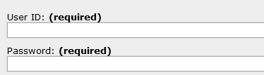  Login
STEP 5 | Click CONTINUE
STEP 6 | Then click “I AGREE” at the next page that opens
 | At the IDENTITY VALIDATION page answer the any one of the questions that will pop up based on the identity verification you would have been prompted to setup and click CONTINUE
STEP 8 | Scroll down at the next page and You will see this Click on CONTINUE APPLICATION as indicated below: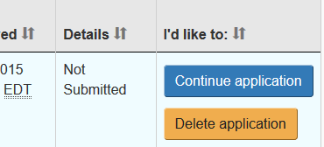
STEP 9 | Click on CONTINUE at the next page
STEP 10 | Click on CONTINUE at the next page again
STEP 11 | At the YOUR DOCUMENT CHECKLIST page complete the attached IMM1294 form and upload at APPLICATION FORM section. See below for directions on downloading the IMM1294 form
 | Note that this document is highly sensitive in the upload process. If uploading is unsuccessful, you will have to manually submit your application.
HOW TO DOWNLOAD FORM IMM1294 FOR ONLINE SUBMISSION
STEP 1 | Go to the YOUR DOCUMENT CHECKLIST page.  You can start from GCkey page  https://clegc-gckey.gc.ca/j/eng/l?ReqID=s26a5a2835210cbc9ca1a4fcae3fe5722e8660dbd9
STEP 2 | Right click on 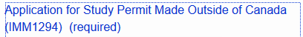 and select SAVE LINK AS and save form IMM1294 on your computer
Step 3 | Upload all forms and documents as indicated at the Documents Checklist page and submit your application online.

